alkyl group:
a functional group that consists only of hydrogen and carbon atoms. It is commonly abbreviated with R when drawing chemical structures. Methyl and ethyl groups are both alkyl groups.
Examples: -CH₃ methyl, -CH₂CH₃ ethyl, -CH₂CH₂CH₃ propyl

aromatic hydrocarbon:
a hydrocarbon that has a cyclic structure (ring) instead of a carbon chain. It is more stable than the chain structure, due to the alternating bonding system.

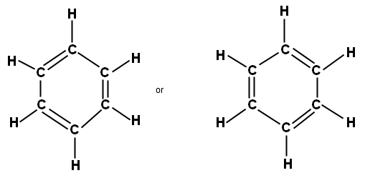
Chemical structure of benzene (aromatic compound)

isomer: a chemical compound that has the same composition, but can vary in structure. The two main types of isomers are structural isomers and stereoisomers.
Example: C₂H₆O
CH₃CH₂OH (Ethanol)
CH₃OCH₃ (Dimethyl ether)

